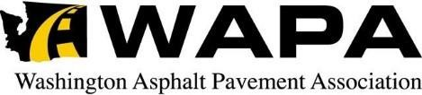

69th ANNUAL MEETING AND
2023 QUALITY PAVING AWARDS

November 3, 2023

A Message from WAPA’s 2023 President
Welcome to the 69th Annual WAPA Awards Banquet. I’m honored to recognize the many and varied “Best Pavement” award winners tonight. I hope you enjoy the evening as much as I always do!
It’s been an honor to serve as the WAPA President this year. I’d like to acknowledge the WAPA Board of Directors for their encouragement throughout the year and I especially want to thank Pamp Maiers, President of Shamrock Paving, for his on-going support of my involvement in WAPA.
I became involved with WAPA over a decade ago, and from the first meeting it was obvious that all the Association members were committed to promoting top quality mix manufacturing and pavement construction, for every application. WAPA could not be as impactful as it has been, since 1954, without the dedicated support of every WAPA member, both Producers and Associates.
As an Association we are dedicated to working with all of our customers to continuously improve pavements for every use and purpose. Whether it’s freeways, bike paths, environmental liners and caps, warehouse lots or airport runways (to name just a few), WAPA works with WSDOT, the FHWA, local agencies and private owners to keep our specifications and training up-to-date, efficient, and effective. We accomplish this through the efforts of the Improving HMA Committee, the WSDOT/WAPA Joint Training sessions, “lunch and learn” meetings, site visits & consultations, project reviews, focused webinars and special committees that address new challenges and new innovations. This year I personally had the opportunity to help with the 35th Annual WSDOT/WAPA Joint Training Conferences, bringing pavement leaders from across the state to learn and to network and to share ideas. Events like these serve to keep our teams on the cutting edge and help us to better connect with all of our customers, both public and private, so that we successfully build great asphalt pavements together, for every application.
In closing, I would like to thank our Annual Pavement Award partners, APWA-WA, WSACE and WSDOT, for their support in recognizing and celebrating high quality paving. Together, we are doing very important work…keeping Washington state rolling down that smooooth asphalt pavement!
Thank you for a great year as President. I would like to be the first to say “Welcome” and “Congratulations” to our 2024 President Elect, Mr. Jaime Lee. I look forward to a great 2024 for Jaime, and to us all!
Scott Willms
2023 WAPA President

2023 Officers and Executive Committee
Scott Willms-Shamrock Paving President Jamie Lee -Lakeside Industries Vice President
Mike Stein-Granite Construction Secretary/Treasurer

Gunnar Gehring- Puget Paving & Member-at-Large
Construction
Michael McBreen-American Rock Member-at-Large
& ICON Materials
Mike Lee-Lakeside Industries NAPA State Director

WAPA Board of Directors
Michael McBreen American Rock & ICON

Pamp Maiers, Jr. Central WA Asphalt

Mike Stein Granite Construction Co.

David Warner Heidelberg Materials

John Madden Inland Asphalt

Mike Lee Lakeside Industries

Brett Schultz Miles Resources

Jeff Motley Motley-Motley Inc

Arnie Wirkkala Naselle Rock & Asphalt

Mark Poe Poe Asphalt Paving

Gunnar Gehring Puget Paving & Construction

Lance Despain Pyramid Materials

Scott Willms Shamrock Paving

Tim Tucci Tucci & Sons

Rob Treece Associate Member Chair

69th Annual WAPA Paving Awards
November 3, 2023
Presentation of Awards
Associate of the Year Award
Commercial Paving - West & East
Heavy/Industrial Paving
Seaport/Intermodal Paving

Airport Paving
APWA 1st Place City Paving Awards -East & West
Special or Innovative Use Paving - East & West
WSACE 1st Place County Paving Awards - East & West
APA – National Perpetual Pavement Awards
- By Performance – WSDOT State & Regional Pavement Offices
- By Design– WSDOT State Design & Regional Offices
- By Conversion – WSDOT State Design & Regional Offices

WSDOT Certificates of Merit -West & East
WSDOT Smoothness Awards -East & West
WSDOT First Place Awards - East & West
Carl Minor Award (Overall Highest Rated Paving Project)
Incoming WAPA President “Black Coat” Presentation

WAPA Past President Gavel Award

ASSOCIATE MEMBER OF THE YEAR AWARD
Presented to
ROB TREECE
US OIL & REFINING CO.
In Recognition of Outstanding Contributions to the WASHINGTON ASPHALT PAVEMENT ASSOCIATION
and the Asphalt Industry

COMMERCIAL AWARD WEST
AMAZON ROXY PROJECT
ARLINGTON, WA
Granite Construction
Mike Stein, Vice President PNW Region
And
PDC SEATTLE, LLC

COMMERCIAL AWARD EAST
MCFARLANE 2 WAREHOUSE PAVING
SPOKANE, WA
Inland Asphalt Paving
John Madden, General Manager
And
DIVCON INC.

HEAVY-INDUSTRIAL WEST

WEYCO LOG YARD 2022 PHASES 1, 2, 3
Lakeside Industries and Weyerhaeuser NR Co./Longview Timberlands
Lakeside Industries, Longview
Mike Lee, President
Ron Green, Regional Manager

-
Weyerhaeuser NR Co./Longview Timberlands

SEAPORT/INTERMODAL
WEST
BNSF SOUTH SEATTLE INTERMODAL FACILITY
ICON Materials and BNSF Railway Co.
ICON MATERIALS
Micheal McBreen, Vice President & G.M.
And
BNSF Railway Co.

HEAVY/INTERMODAL EAST
Airway Heights Amazon Distribution Center

Inland Asphalt Paving Company
John Madden, General Manager
_
DIVICON INC.

SEAPORT/INTERMODAL PAVING
NORTON TERMINAL
Granite Construction Co. and Port of Everett
Granite Construction
Mike Stein, Vice President PNW Region
-
Port of Everett

Lisa Lefeber, Executive Director

AIRPORT PAVING
Arlington Municipal Airport Runway 16-34
Lakeside Industries – Monroe Division and
DOWL
Lakeside Industries - Monroe
Mike Lee, President
Todd Prodzinski, Regional Manager
-
Arlington Municipal Airport
David Ryan, Airport Director

APWA 1ST PLACE CITY
PAVING AWARD EAST
City of Walla Walla - Reconstruction of Alder
& Poplar Streets
Merriam to Colville Street

Central Washington Asphalt
Pamp Maiers, President

City of Walla Walla
Ki Bealey, P.E. – Director, City of Walla Walla PW

APWA 1ST PLACE CITY
PAVING AWARD WEST
City of Camas - Contract T1038 –
NW Sierra Street Resurfacing

Lakeside Industries, Vancouver Division
Mike Lee, President
Ron Green, Regional Manager
Randy Gartner, Operations Manager

City of Camas
Steve Wall, City of Camas Public Works Director

SPECIAL / INNOVATIVE USE - EAST

Spokane County CRP 2991
Bigelow Gulch Road Project 6
Full Depth Reclamation & Paving

Inland Asphalt Paving Company
John Madden, General Manager
Spokane County Public Works &

N.A. Degerstrom
General Contractor

SPECIAL / INNOVATIVE USE - WEST

Pierce County CRP 5880 – Point Fosdick Drive NW
Crack, Seat & Overlay Pavement Rehab.

Miles Resources
Walt Miles, President
Lisa Kittesby, Principal
Joe Harrison, General Manager

-

Pierce County Planning & Public Works
Andrew Davis, P.E., Cons’t. Engineering Supervisor

WSACE 1ST PLACE COUNTY
PAVING AWARD EAST

CRP 453 – N. Deadman & Gould City/
Mayview Corridor – Pavement Preservation

Poe Asphalt Paving and Garfield County

Poe Asphalt Paving
Mark Poe, President

Garfield County
James Wege, P.E., County Engineer

WSACE 1ST PLACE COUNTY
PAVING AWARD WEST

Pierce Co. CRP 5913 – Waller Road East
72nd St. East to Pioneer Way East Vic.

Puget Paving and Pierce County

Puget Paving & Construction, Inc.
Gunnar Gehring & Stefan Gehring, Principals

-

Pierce County Planning & Public Works
Melissa McFadden P.E., County Engineer

APA PERPETUAL PAVEMENT
AWARDS

APA Perpetual Pavement “By Performance” Award
State Route 2 - Milepost 46.05 to Milepost 48.72
WSDOT Northwest Region

APA Perpetual Pavement “By Design” Award
SR 167 – Milepost 14.40 to Milepost 18.24
WSDOT Northwest Region
Atkinson Construction & Miles Resources

APA Perpetual Pavement “By Conversion” Award
Interstate 5, Milepost 45.5 to Milepost 49.91
WSDOT Southwest Region

Karen Carlie, State Pavement Materials Engineer

Karen Strauss, State Pavement
Management Engineer

Brian Nielsen, NW Region Administrator

Carley Francis, SW Region Administrator

Chad Lundgreen, State Pavement
Research Engineer

Kyler Carlson, Pavement Analysis Engineer

WSDOT CERTIFICATE OF
MERIT - WEST

Contract 9429 – Interstate 90
Eastgate to SR 900 Corridor Improvements

WSDOT NW Region & Lakeside Industries

Lakeside Industries, Seattle/Eastside
Mike Lee, President
Todd Prodzinski, Regional Manager

WSDOT Project Engineer
James Harper, P.E.

WSDOT CERTIFICATE OF
MERIT - EAST

Contract 9806 – Stevens Pass East Paving
WSDOT NC Region & American Rock Products

American Rock Products
Michael McBreen, VP/General Manager

WSDOT Project Engineer
Miguel Castillo, P.E.

WSDOT CERTIFICATE OF
MERIT WEST
Contract 9636 - SR 410 TO SR 18
Congestion Management

WSDOT Olympic Region, Graham Contracting
and Miles Resources

WSDOT Project Engineer
Justin Janke, P.E.
Graham Contracting Ltd
Drew Williams, Project Manager
Miles Resources
Joe Harrison, General Manager

WSDOT CERTIFICATE OF
MERIT EAST
Contract 9752
Dodson Road to Adams Co. Line - Paving

WSDOT North Central Region &
Central Washington Asphalt

Central WA Asphalt
Pamp Maiers, President

WSDOT Project Engineer
Jeff Deal, P.E.

WSDOT SMOOTHNESS
AWARD EAST
Contract 9759
US 2 – Davenport to Reardan Paving

WSDOT Eastern Region & Inland Asphalt Paving

Inland Asphalt, a CRH Company
John Madden, General Manager

WSDOT Eastern Region
Tom Brasch, P.E. & Alex Proszek, P.E.

WSDOT SMOOTHNESS
AWARD WEST
Contract 9429
I-90 Eastgate to SR 900 Corridor Improvements

WSDOT NW Region & Lakeside Industries

Lakeside Industries – Seattle/Eastside
Mike Lee, President
Todd Prodzinski, Regional Manager
-
WSDOT Project Engineer
James Harper, P.E.

WSDOT FIRST PLACE EAST
Contract 9759
SR 2 – Davenport to Reardan Paving

WSDOT Eastern Region & Inland Asphalt Paving

Inland Asphalt Paving Co.
John Madden, General Manager

WSDOT Project Engineers
Tom Brasch, P.E.
Alex Proszek, P.E.

WSDOT FIRST PLACE WEST
Contract 9755
I-405 & SR 92
SR 520 Vic. & I-5/SR 9 Vic. Paving

WSDOT NW Region & Lakeside Industries

Lakeside Industries – Monroe Division
Mike Lee, President
Todd Prodzinski, Regional Manager
-
WSDOT Project Engineer
Amelia Scharrer, P.E.

CARL MINOR AWARD
2022 Highest Rated
WSDOT Paving Project

Drumroll Please…

And the winner is……

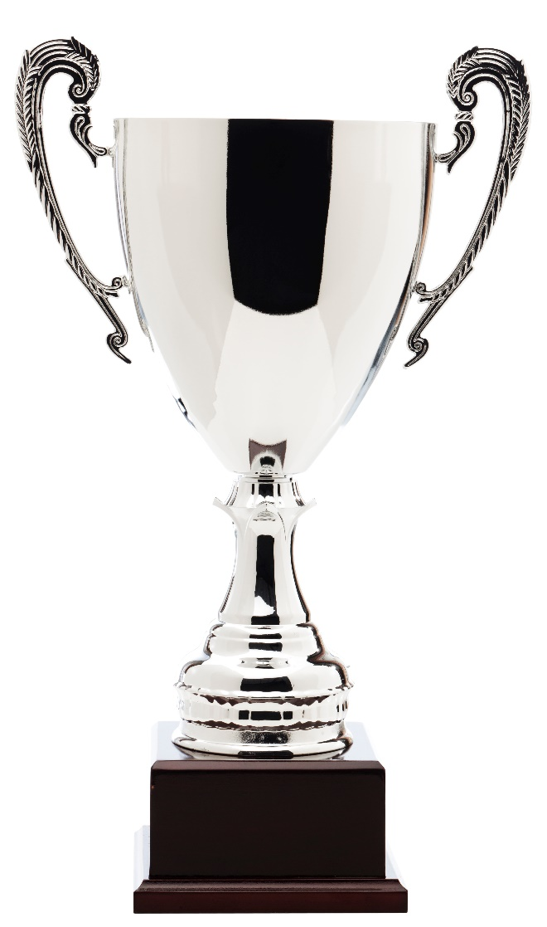
Awards

Incoming President
“Black Coat” Award

Jaime Lee
Lakeside Industries

Past President Award

Scott Willms
Shamrock Paving

A VERY SPECIAL THANK YOU TO OUR ASSOCIATE MEMBERS
WHO GENEROUSLY SPONSORED OUR 2023 SOCIAL HOUR

AD-TEK, INC.
ALBINA ASPHALT
BOMAG
CALPORTLAND
CONSTRUCTION TESTING LABS
ERGON ASPHALT
HAULHUB
IDAHO ASPHALT
MATCON
MODERN MACHINERY
P.R. SYSTEMS
PACIFIC GEOSOURCE
PACWEST MACHINERY
PAPE MACHINERY
PORTER W YETT
PROPEL INSURANCE
SEAPORT TERMINALS
US OIL & REFINING

WE APPRECIATE ALL YOU DO FOR THE ASSOCIATION!
Washington Asphalt Pavement Association WAPA
451 SW 10th Street Suite 110A Renton, WA 98057 www.AsphaltWA.com

