THE MANY BENEFITS OF ASPHALT PAVING
- Asphalt is Smooth

Asphalt is a flexible pavement that is constructed layers in a continuous flow of material moving through highly specialized asphalt paving equipment. Because there are very few joints needed when constructing the road, asphalt pavements are inherently smooth and the provide a quiet ride that the public instantly recognizes and enjoys. Smooth asphalt pavements maximize fuel efficiency and minimize wear and tear on vehicles. The smooth ride also leads to longer pavement life.

- Asphalt is Cost-effective

Asphalt consistently has the lowest initial costs for high quality pavements, it lasts longer (or forever – see below) with proper maintenance and, due to its recyclability, has greater residual value and lower future maintenance costs than other pavements.

Quick fact: 94% of all pavement surfaces in the U.S.A are asphalt surfaces. When all the factors are weighed, this fact is a testament - The market forces inherent in our free enterprise and competitive bid public works systems resoundingly choose asphalt as the preferred paving material.

- Asphalt Pavements can be Staged

Asphalt pavements can be built-up over time (staged) to fit the construction and cash flow needs of a project. Staged construction involves placing the initial pavement structure and first layer(s) of asphalt early and then placing the final asphalt surface layer after all building construction has been completed. This allows for an all-weather working surface on site, which in turn allows clean and easy access for delivery trucks, clean storage of building materials, a clean, hard surface to work upon and deferment of the costs of a portion of the pavement until the entire project is fully complete. Another big plus - you get a brand-new pavement surface on opening day, enhancing the beauty of your project.

Staged pavement construction can be a real money saver for builders and developers. Don’t work in the mud or the dust! Stage your project with asphalt pavements.

- Asphalt is Versatile and Adaptable to Any Paving Need
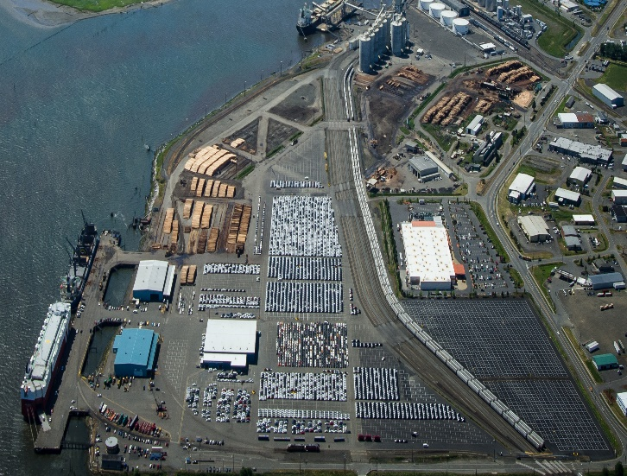
Airports? Done that. 85% of all general aviation airport runway pavements in the U.S. are asphalt. The bulk of new Boeing planes are tested, finalized and/or delivered from Paine Field, Boeing Field and Renton Airport. All of these runways are paved with asphalt.

Seaports? Paved with asphalt all over the world.

Container facilities? Well-designed asphalt pavements can stand up to any demand.
Port of Gray Harbor WA Lumber & Auto Import/ Export Facilities
The versatility of modern asphalt mixes and construction techniques allow for designing a variety of structurally robust pavements that can meet intense load and service demands, as well as the economic needs of any project. Asphalt pavements can meet any operational challenges your project may face.

- Asphalt is Safe
The smooth surface of an asphalt pavement provides maximum tire contact with the roadway, increasing skid resistance and decreasing stopping distance. And, because of the fractured aggregate used to produce high-quality highway grade asphalt pavements, skid resistance is maintained for the life of the pavement.
The dark color of asphalt also reduces glare, helps to melt snow and ice and provides a high contrast for lane markings. This also enhances the effectiveness of the newest features in modern cars (semi-autonomous driving mode/ lane departure warnings) that partially rely on good pavement markings.
- Asphalt is Fast to Construct

Most drivers have experienced the minor miracle of traveling over an older surface one day and then driving on a super-smooth new asphalt pavement the very next day. Because asphalt needs very little time to cool and be compacted into its final configuration, motorists can use roadways as soon as the last roller leaves the construction zone. In urban areas, asphalt crews often work the night shift to construct a new surface, literally, overnight. This speed of construction advantage results in minimal delays, fewer construction work zones and safer roads for the traveling public.

- Asphalt is Durable
Asphalt is a flexible pavement. This flexibility allows asphalt to withstand occasional overloading of the pavement and to adapt to seasonal environmental fluctuations. Did you know that today’s asphalt pavements use asphalt cement (the “binder” in an asphalt mix) customized to best fit specific climatic regions of the country? These “Performance Grading” binders allow asphalt pavements to closely match the structural needs dictated by the environment. The newest generation of asphalt pavements are highly resistant to rutting, even in the highest heat of summer, and they also adapt to the harsh freeze / thaw cycles experienced in some regions of Washington during winter.
- Asphalt is a Perpetual Pavement

When properly designed, asphalt pavements can be constructed to last indefinitely. These pavements are known as Perpetual Pavements. These full-depth/ deep-strength pavements are built using layers of high quality materials (crushed rock and asphalt paving) that is finalized with the construction of the smooth, durable asphalt wearing course. These pavements will never fail structurally. The top few inches can be milled off every 18-20 years and repaved to create a new pavement surface. Additionally, the milled asphalt can be 100% reclaimed and recycled into new pavements. The intermediate and base courses of these pavements remain strong and viable without ever needing reconstruction.

- Parking Lots Can Be Perpetual Too!

Asphalt is so adaptable and durable, it is used for a wide-spectrum of paving needs, from super highways to residential driveways, with equally excellent results. An asphalt pavement, in any application, can be renewed indefinitely. For instance, a parking lot pavement, with proper maintenance, never has to be reconstructed. Periodic cleaning and planned surface re-sealing approximately once every ten years will keep a parking lot attractive and fully functional for many decades. A home owner can do this same cleaning and maintenance on a driveway, using common tools and sealing products available at home improvement stores.

- Asphalt Roads Enhance and Blend with the Environment
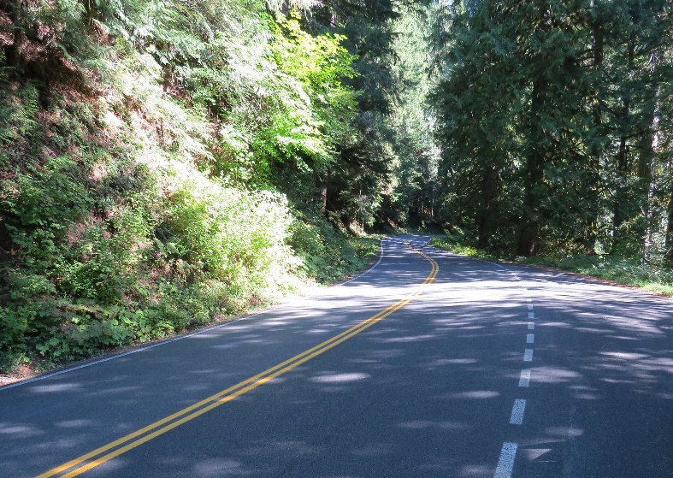
Drive a sinuous, curving road through almost any scenic landscape in “America the Beautiful” and you’re almost sure to be driving on an asphalt road. In the U.S.A., our love of the road and the beauty of our country are almost always experienced by access over an asphalt pavement. Paved National Park Service and U.S. Forest Service roads are nearly always asphalt roads. For example, in Washington state, the roads through Mt. Rainier National Park are lovingly referred to as “the velvet ribbon” by Park Service personnel. It’s a scene we can all visualize in our mind’s eye.
Mt. Rainier National Park
- Asphalt is 100% Recyclable
Asphalt is America’s #1 recycled product. Approximately 80 million tons of asphalt pavements are reclaimed and recycled each year, saving the American taxpayer over $1.5 billion dollars. This highly refined “closed loop” recycling process makes asphalt pavements sustainable and renewable. Both the aggregates and the asphalt cement (binder) are typically fully reused, resulting in the need for less future aggregate mining and less new asphalt from petroleum to produce tomorrow’s new high-quality asphalt pavements.
- Porous Asphalt Pavements Can Help Meet Modern Permitting Requirements
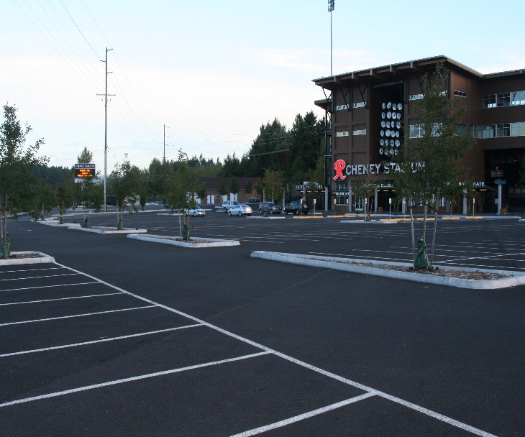
Western Washington is famously known for its wet climate and beautiful waterways. Porous asphalt pavements are increasingly being utilized to manage storm water through the storage and slow release of rain water under the pavement.
A properly designed porous asphalt pavement solves storm water runoff concerns, eliminates standing water on the parking lot and generally eliminates the need for extensive drainage or retention systems on the site. The ability to eliminate the extra land and construction features needed for a traditional on-site retention system often more than pays for the cost of a porous asphalt pavement.
Porous Parking Lot @ Cheney Stadium, Tacoma WA
If your site cannot add impervious surface areas (in order to comply with modern storm water permit regulations), porous paving may be your only cost-effective option for developing the site.
As a bonus, did you know that porous asphalt pavements have been shown to be effective in passively treating storm water runoff? The pavement effectively reduces suspended solids as well as “treating” by natural process, many of the trace chemicals and heavy metals present in parking lot storm water. Porous pavements even improve snow melt effectiveness in the winter! Porous asphalt pavements are an innovation worth exploring.
- Asphalt Can Help Recycle Other Select Waste Products
Today’s asphalt production industry routinely recycles used asphalt pavements every day, but did you know that modern asphalt pavements often include recycled tire rubber, steel foundry slag or recycled asphalt roofing shingles too? The asphalt industry has recycled millions of tons of discarded tires, slag and old asphalt shingles nationwide over the last 20 years. Research is on-going for responsible use of glass, carbon fiber and plastics too, just to name the most prominent current research tracks.
The amount of local recycling of non-traditional materials largely depends on the region of the country and the local market dynamics, but where it makes economic and environmental sense, and where the quality of the pavements can be enhanced, the asphalt you are driving on today may have some unexpected “waste” materials incorporated into the asphalt.
Important note: While the asphalt paving industry leads the nation in recycling and innovation, asphalt pavements are not “linear landfills”. Incorporating recycled materials, of any type, should only be championed and specified when it can be certified that the final pavement quality will not compromised. Designing asphalt mixes with non-traditional additives requires significant research, rigorous material science investigation and the production of the mixes often require considerable capital investment.
Final Answer: Asphalt is the Best Choice
For the reasons listed above and due to many other more nuanced reasons not listed, the advantages of asphalt simply add up to superior value. Asphalt is safe, smooth and durable. It can be built to be an everlasting perpetual pavement. Asphalt is fast to construct, and asphalt contractors know how to “get in and get out” of construction zones. Asphalt is the green and sustainable pavement: It is 100% recyclable and modern practices and technology make asphalt the only fully reclaimable pavement.

Choose the Smooth Pavement. Choose the Fast Pavement. Choose the Safe Pavement.
Choose the Green, Sustainable, Economical and Versatile Pavement.
Choose the Right Pavement.
Choose Asphalt!

Please note - Many of the statements and statistics used to create this document were drawn from similar summaries by the Asphalt Pavement Alliance (APA) and sister State Asphalt Pavement Associations (SAPAs).

