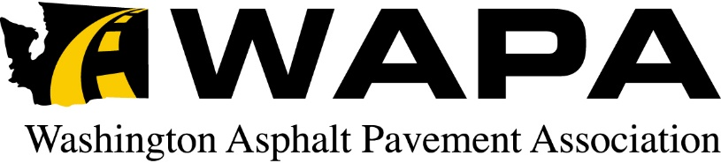

March 15, 2016

To: All Members

From: David Gent, Executive Director

Re: 2016 WAPA Mid-Year Meeting

**PLEASE MARK YOUR CALENDARS**

The Washington Asphalt Pavement Association (WAPA) will hold its Mid-Year Meeting May 18 – 20, 2016 at The Coeur d’Alene Resort, Coeur d’Alene, ID.

The Board of Directors will meet on Wednesday, May 18th from 1:00pm to 3:00pm at the Resort. The Associate Member Council will meet from 2:30pm to 3:00pm also on Wednesday. The Board of Director’s Dinner (by invitation only) will follow that evening.

The Golf Tournament and Banquet will be held on Thursday, May 19th. The Tournament is scheduled for the Coeur d’Alene Resort course. Our Mid Year business meeting will be held on Friday, May 20th from 8:00am until noon. An agenda for the meeting will be sent at a later date as well as the registration form for the meeting.

Please make your room reservations now by calling (800) 688-5253 and refer to the Washington Asphalt Pavement Association room block. Reservation cut off is April 25th. Availability of rooms after that date cannot be not guaranteed. Room rates arranged through WAPA are Traditional ($153/night), Deluxe ($188/night) & Premier ($238/ night).

Please give Cindy or me a call if you have any questions.

